Display Screen: Select on/off till backing blue light comes on
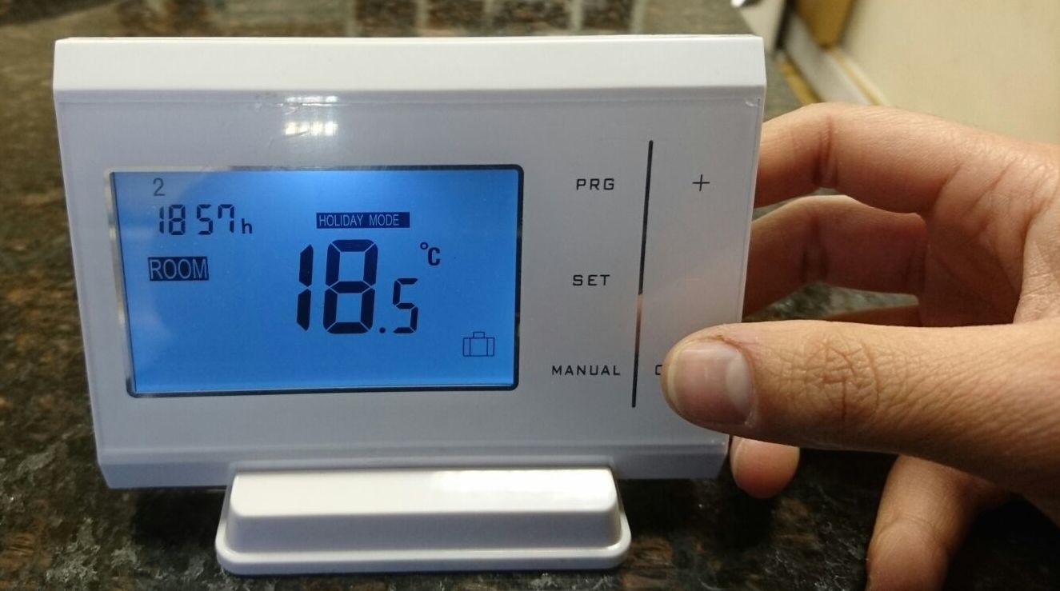
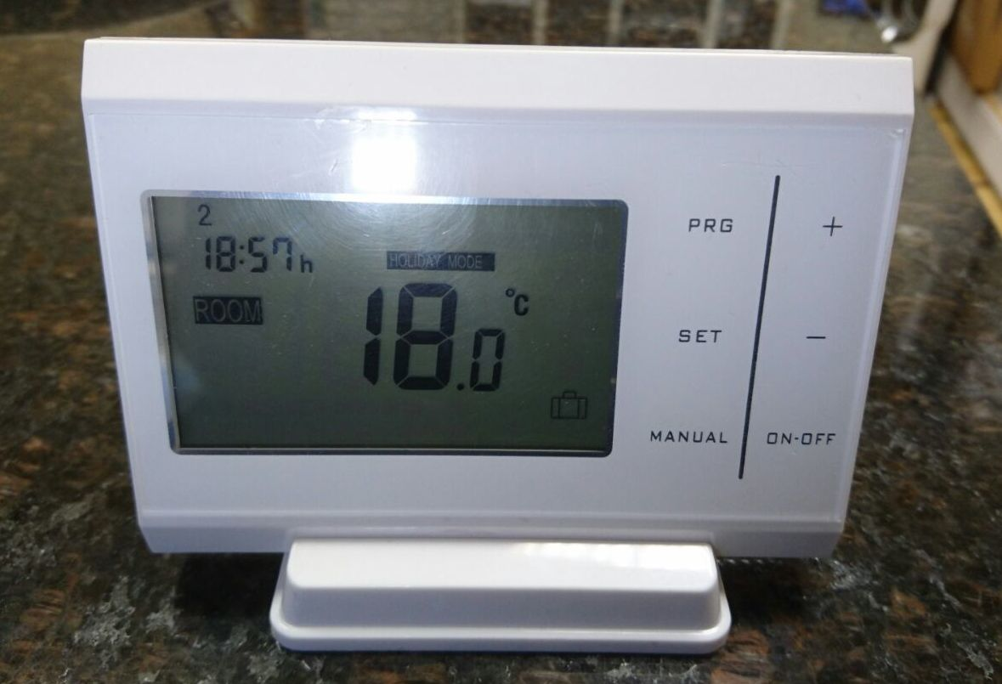

Device Setup.

Pressing the set button allows you to set the current time to the device.
Use the + and - accordingly.
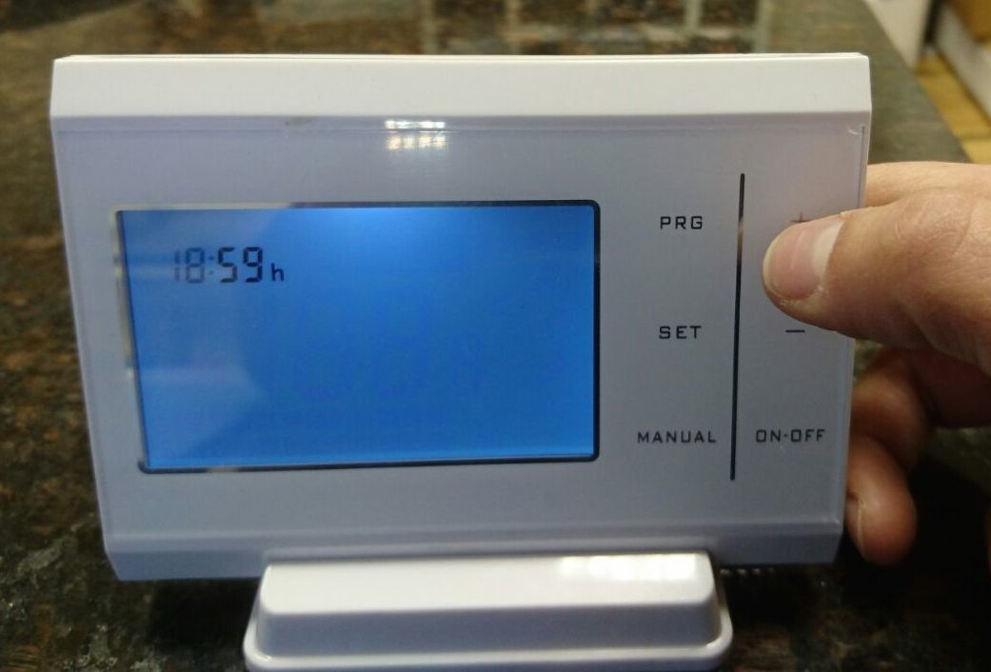
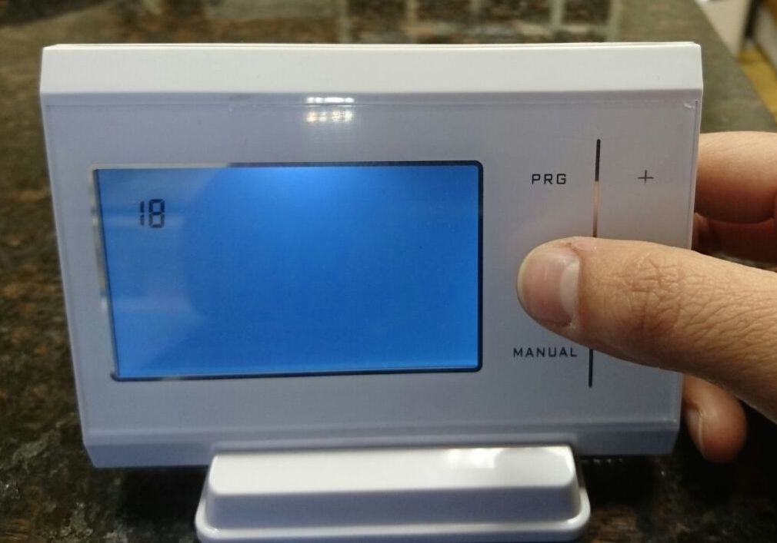

Press the set button again you can set the current day.
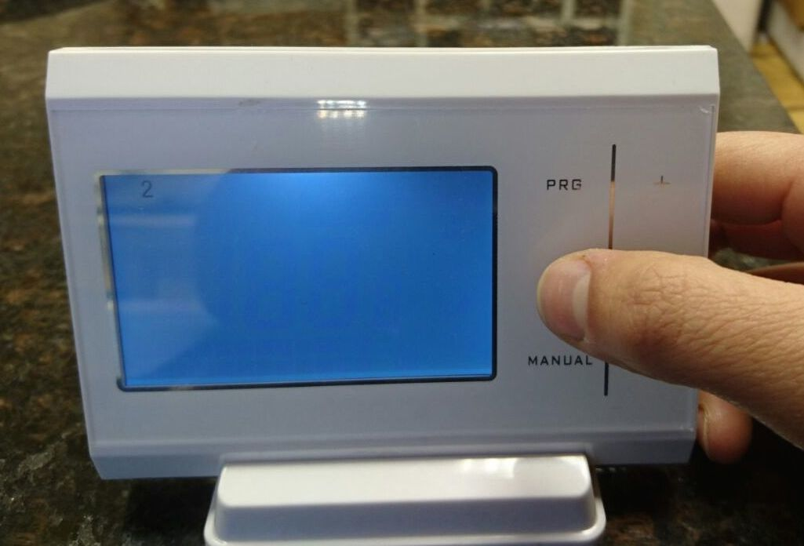
You will see the days listed at the top from 1-7.
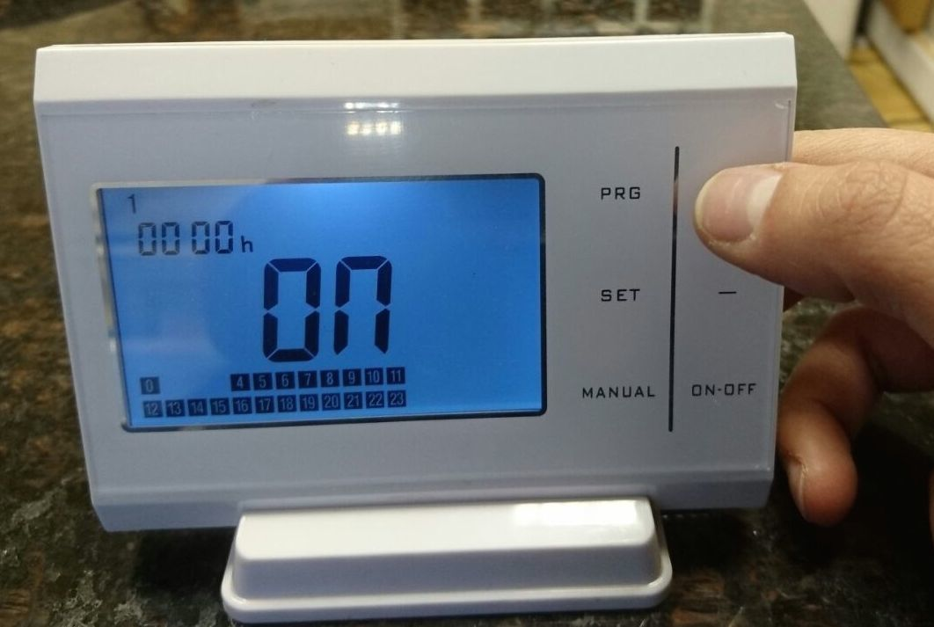
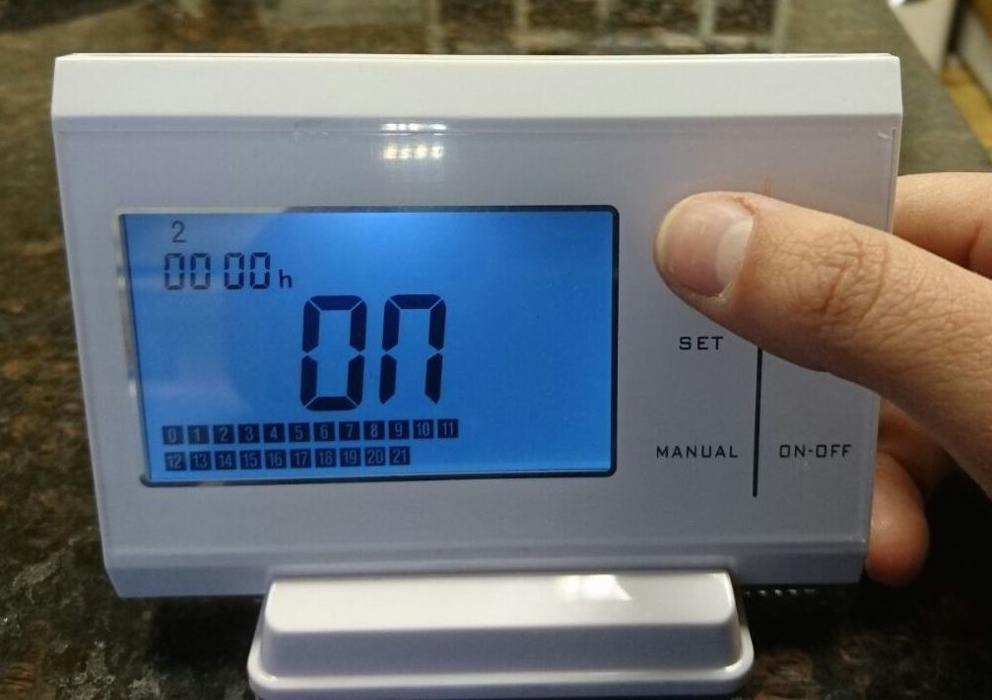
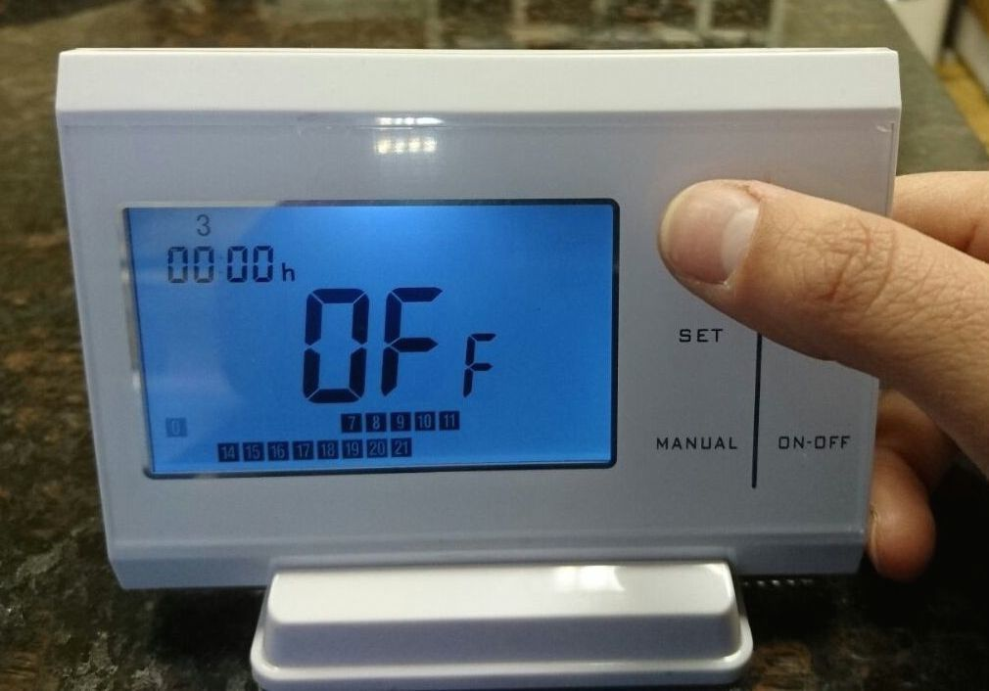
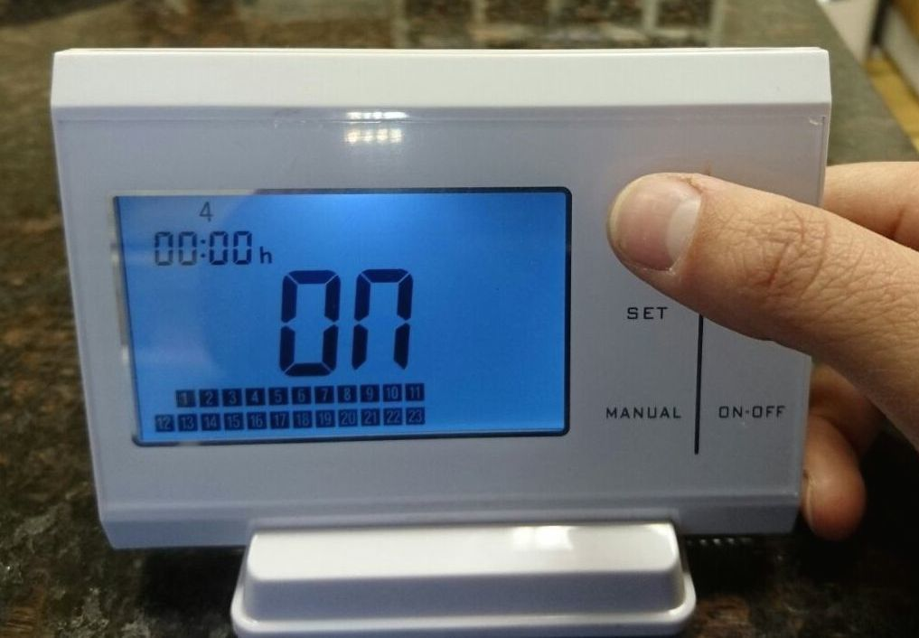
By pressing PRG you can flick through the days.

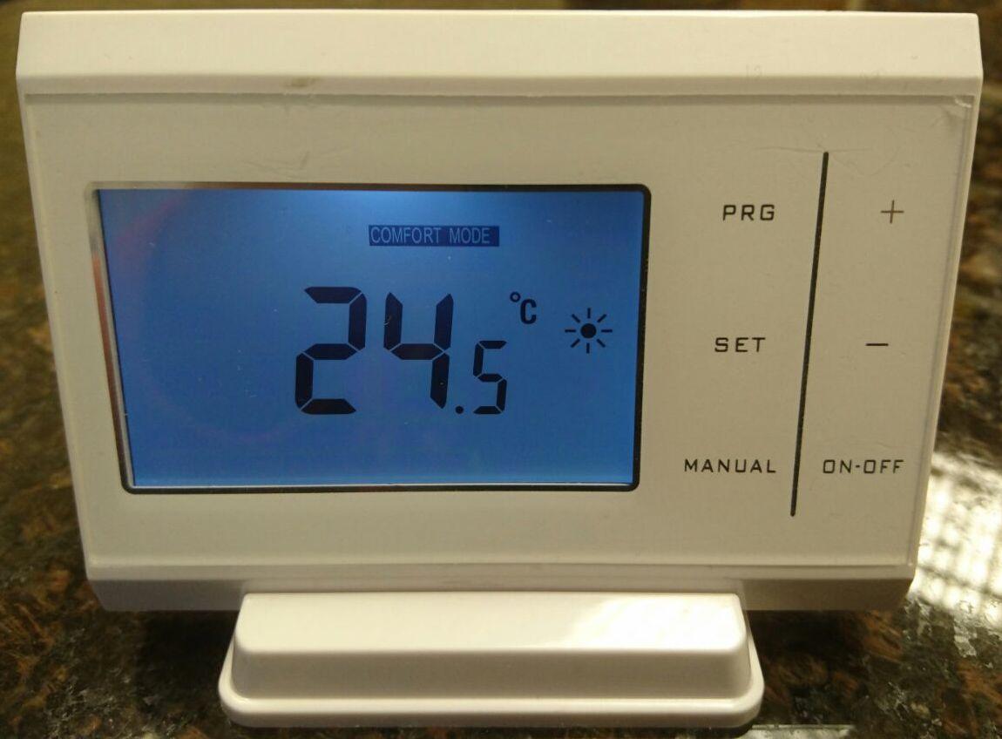
Pressing the set button you can also set the following modes as you wish: Comfort, Economy and Holiday.
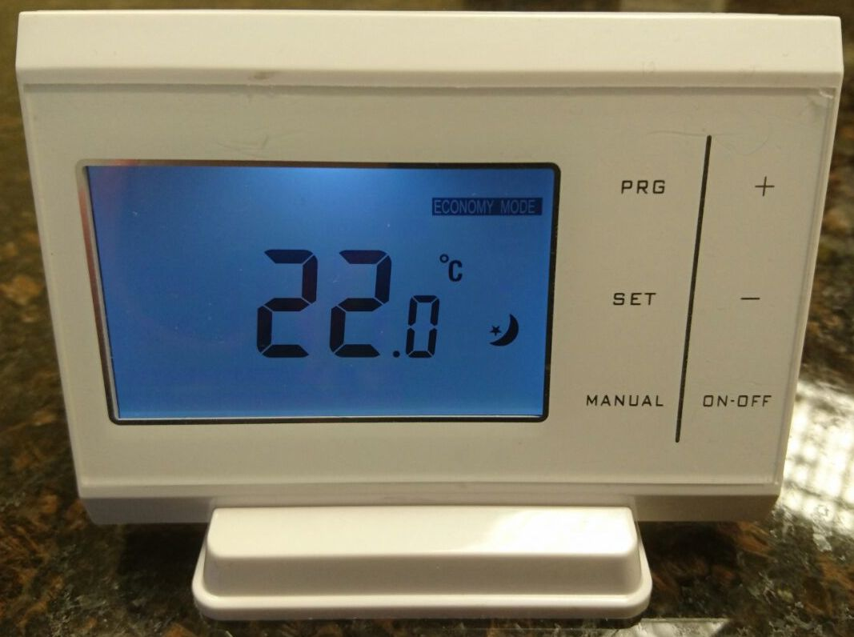
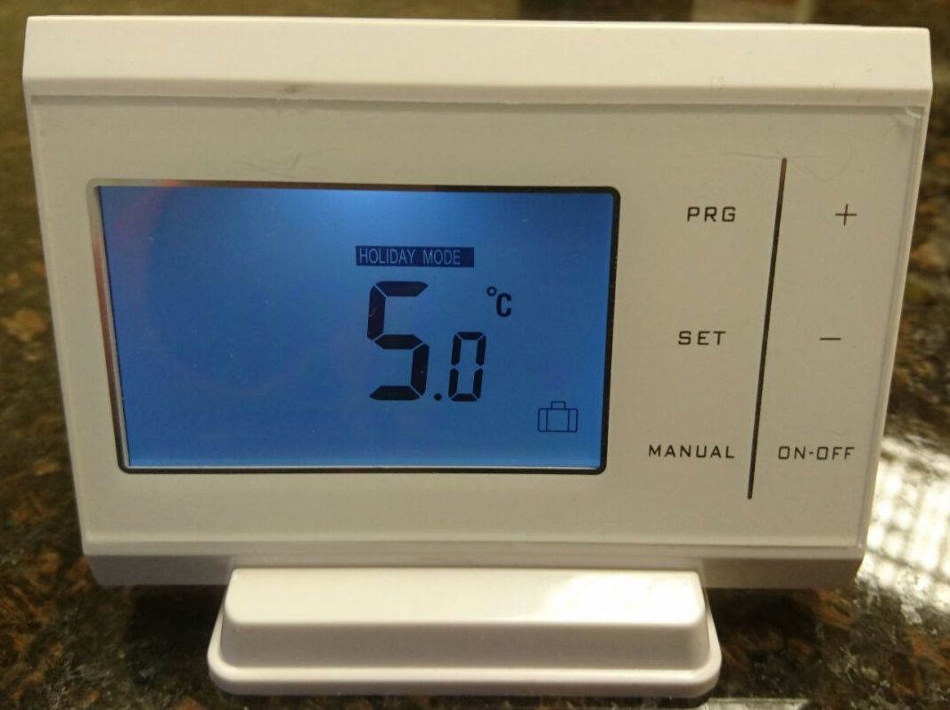

Once you are happy leave the device and it will return to its Default screen.
(See first picture)

Display Screen: Select on/off till backing blue light comes on.

Programming the device

By selecting manual, you will see 4 modes: Eco - Comfort - Holiday - Programmable.

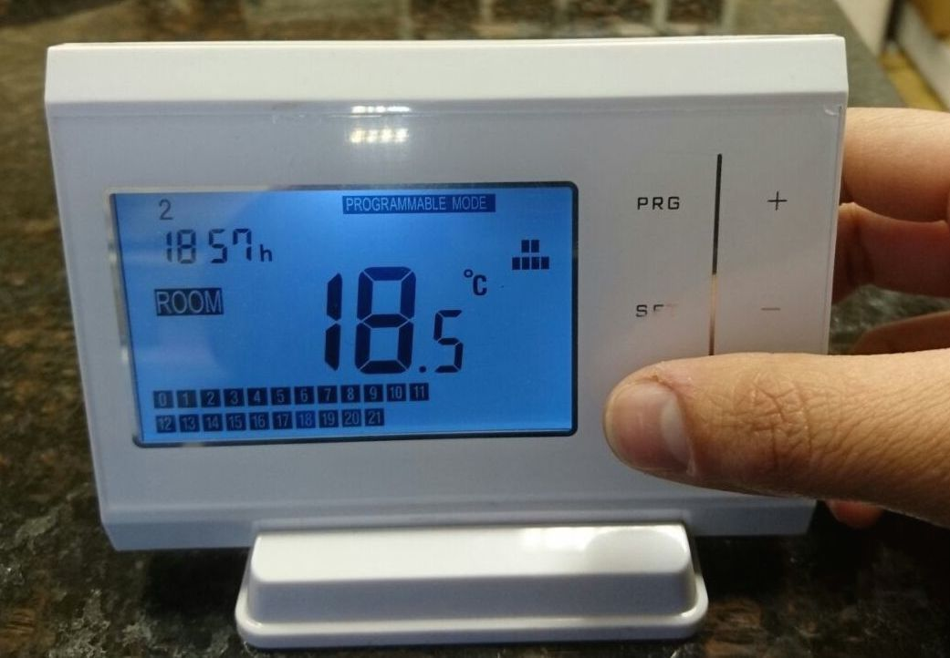
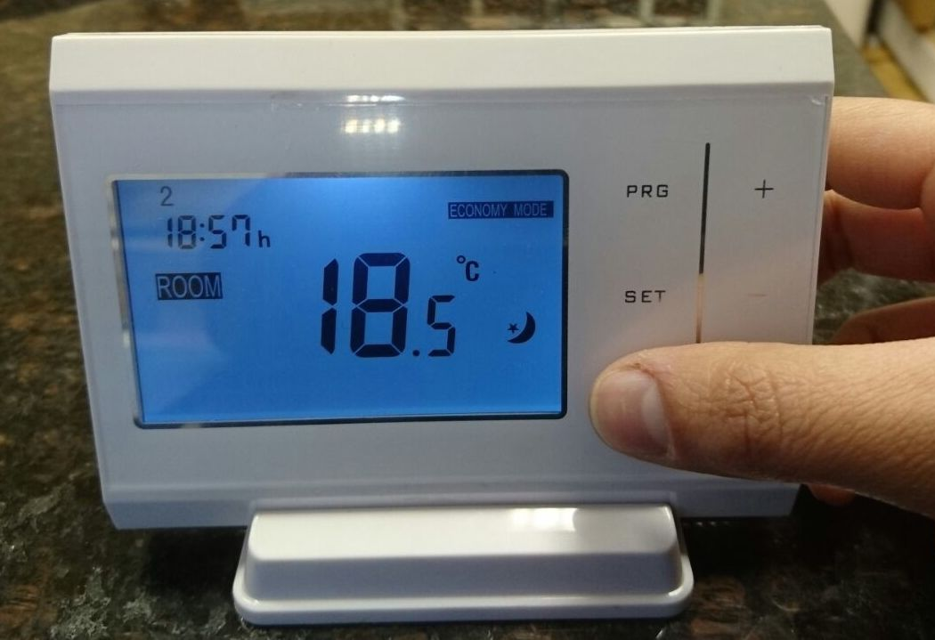

When you see programmable mode hold down the PRG button till the display changes from:
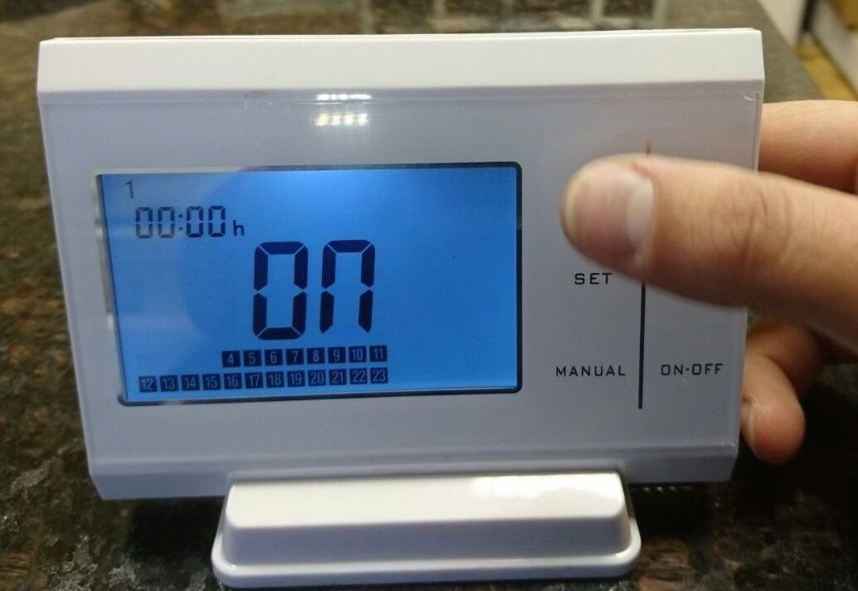
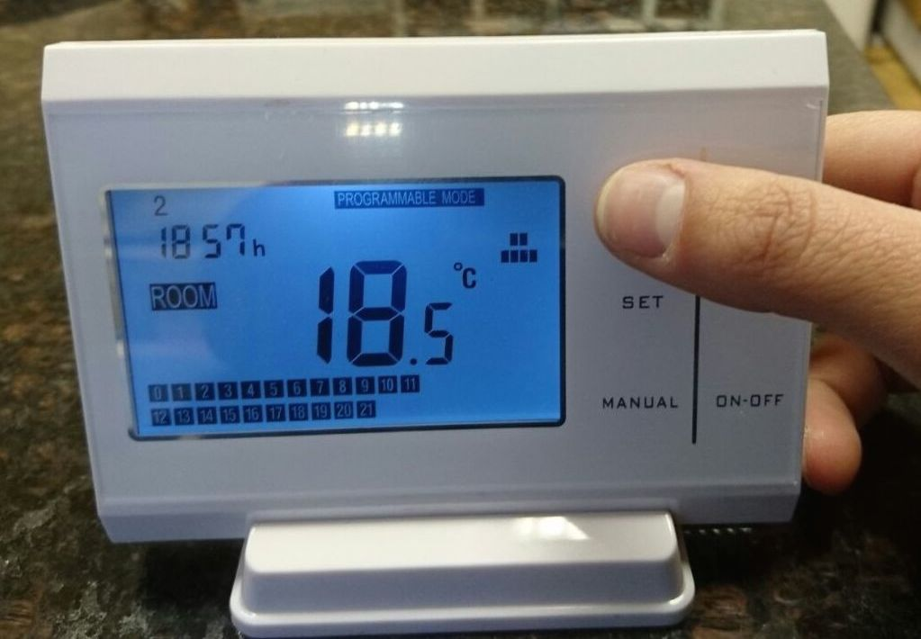

You will see the days listed at the top from 1-7. By pressing PRG you can flick through the days.
You can also see the hours of the days 0-24 highlighted in the boxes at the bottom.

Selecting the Manual button you are able to turn the boiler ON or OFF
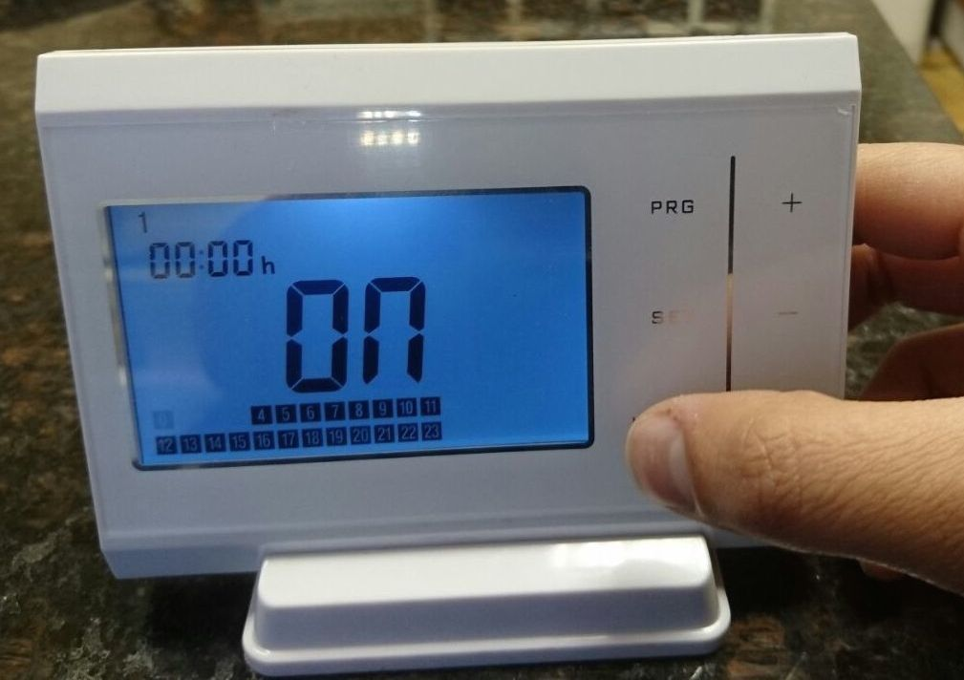
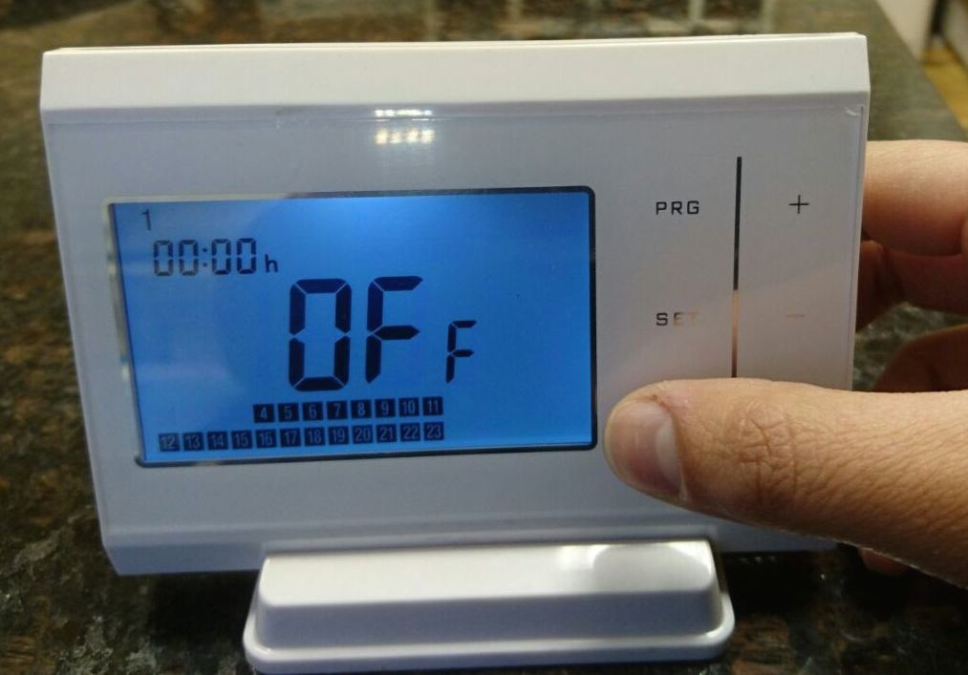

The + and - buttons allows you to select which hours you’d like the boiler on for
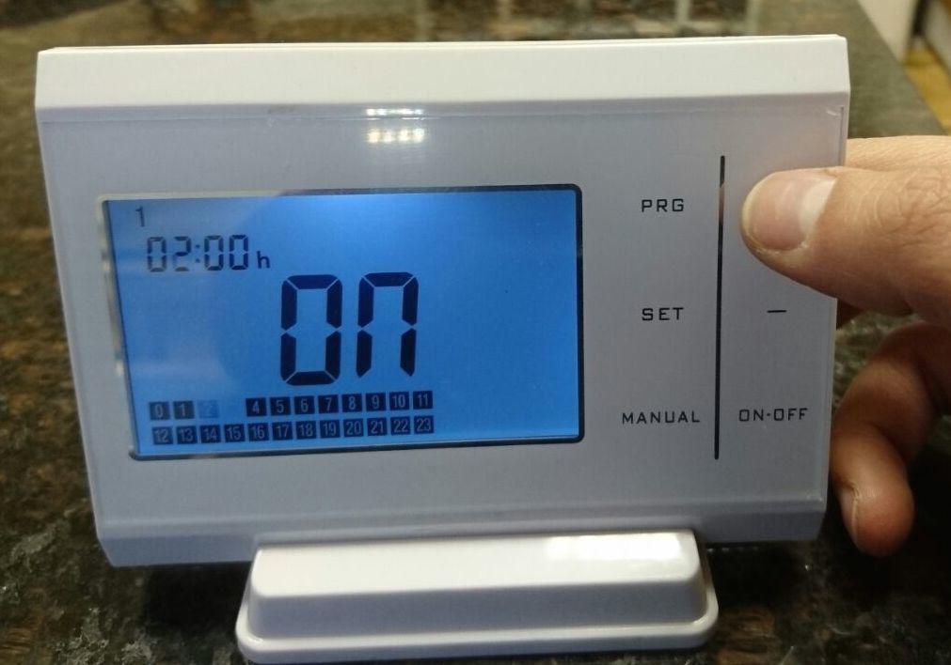

You can now program you boiler as you like.

